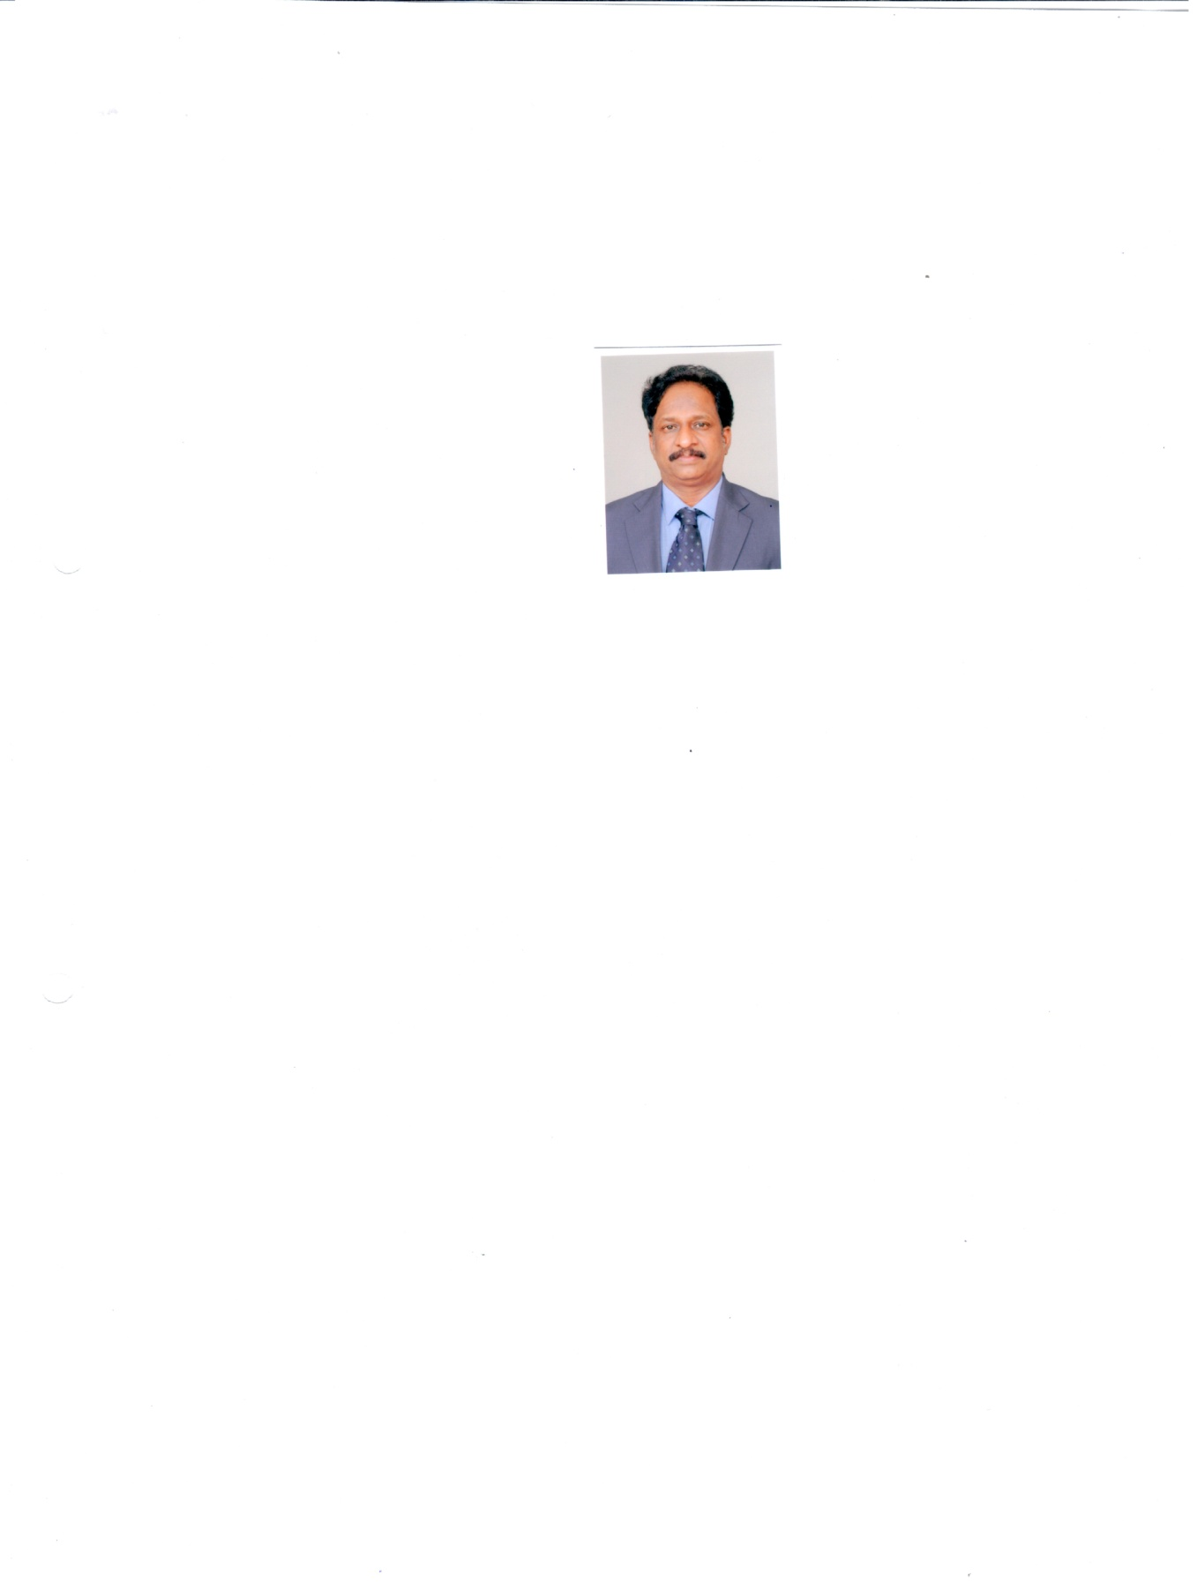Dr. Natesan Manickam

Date of Birth: June 05, 1965

Head, Environmental Biotechnology 0522-2620107; ext. 246,

Prof.-AcSIR Cell: 9450110787.

*Area Co-ordinator:* Environmental Toxicology E-mail: nmanickam@iitr.res.in

CSIR-Indian Institute of Toxicology Research

*Vishvigyan Bhawan,* 31, Mahatma Gandhi Marg

Lucknow-226 001, UP.

----------------------------------------------------------------------------------------------------------------**Education**

Ph.D. Microbiology Guru Nanak Dev University, Amritsar. 2009 ----

M.Tech. Biotechnology Anna University, Chennai. 1990 First

M.Sc. Botany University of Madras, Chennai. 1988 First

B. Sc. Chem, Zoo, Bot. University of Madras, Chennai. 1983 First

+2, Hr Sec Tamil Nadu Secondary Edu. Board 1981 First

--------------------------------------------------------------------------------------------------------------**Professional Experience**

|  |  |  |
| --- | --- | --- |
| **Post held:**  January 1990-January 1995 | Scientist B | Biotechnology Section, (CSIR-IITR), Lucknow. |
| Feb. 1995- January 2000 | Scientist C | -do- |
| Feb. 2000- January 2006 | Scientist-EI | -do- |
| Feb 2006 - January 2011 Principal Scientist -do-  Feb. 2011 – till now Sr. Principal Scientist -do-  ------------------------------------------------------------------------------------------------------------ | | |

**Awards and Fellowships**

**DAAD (Deutscher Academischer Austausdienst) CSIR-DAAD: Long term** fellowship award, **1998-2000**

Indian National Science Academy **(INSA-GFB)** German Research Foundation short-term fellowship award, **2007.**

**Norman E. Borlaug Fellow** for International Agricultural Science and Technology, **2009**

**------------------------------------------------------------------------------------------------**

**Membership in Academic and Professional Societies, Life member in,**

Society of Biological Chemists **(SBC**), India. 1993-present

Society of Toxicology **(STOX),** India 1995-present

Association of Microbiologists India **(AMI),** 1995-present

Indian Network for Soil Contamination and Research **(INSCR),** India. 2000-present

Biotechnology Research Society of India **(BRSI),** India 2006-present

German Association for General and Applied Microbiology **(VAAM),** Germany. 1998-

American Society for Microbiology (ASM), USA 2014-present

**--------------------------------------------------------------------------------------------------------**

**National Responsibilities and Association**

Member: **Genetic Engineering Approval Committee (GEAC**) under the Ministry of Environment and Forests. This committee serves to approve /appraise for the import and export of GM food, feed and other biologically derived hazardous materials in the country. **Two terms for the period 2007-09, 2009-12.**

**Monitoring and Evaluation Committee (MEC):** Under MoEF for GM crop Field trails, 2009-2012

**Task Force Member:** Department of Biotechnology (DBT), Govt of India, on Special Task Force for “Bioremediation Technologies”. **Period 2011-12. --------------------------------------------------------------------------------------------------------**

**Professional Training Undergone**

**A Post Graduate diploma course on** Intellectual property rights **(PGD-IPR), was studied at** National Law School of India University (NLSIU), Bangalore (ID No. IPR 1538/2006): (course is not completed)

**Experience on Good Laboratory Practices (GLP),** Training received on Good laboratory Practices (GLP) organized by UNDP / World Bank / WHO at Hotel Imperial, New Delhi, December 3-5, 2003.

**The Safety Assessment of Foods Derived from GM Crops,** training received at CSIR IITR Lucknow from Sept-25-29, 2006. The workshop was organized jointly by SOUTH ASIA Biosafety program, agbios and BCIL, India.

**American Society for Microbiology (ASM),** Molecular Ecology of Biodegradation Short Course Institute of Microbial Technology (CSIR), Chandigarh, India. 6–17 December 2004.

Several courses related to the **‘Biotechnology, Molecular biology, Microbiology and Bioinformatics**’ have been attended during my last more than 20 years of research work.

----------------------------------------------------------------------------------------------------------------

**Research experience abroad:**

|  |  |  |
| --- | --- | --- |
| Period | Place | Work |
| Oct. 1998-Sept. 2000 | Institute of Microbiology University of Stuttgart, Stuttgart **Germany** | Molecular cloning and characterization of lindane degradation genes from a *Microbacterium* sp. |
| Oct. 2007-Dec.2007 | Technical University Bergakademie, Freiberg, **Germany** | Cloning and expression of a haloalkane dehalogenase from a *Sphingomonas* sp |
| July-Aug. 2009. | Washington State University, Pullman, **USA** | Biosafety of Transgenic Crops. Regulatory Consultation with US-FDA |

----------------------------------------------------------------------------------------------------------------

**Editorial Member:** Member of Editorial Team in ***Indian Journal of Microbiology.* 2012- present**

**Workshops conducted:** 3, as Organizing Secretary

**National and International conferences organized:** 5, Co-chairman & Sci. Prog. convenor.

---------------------------------------------------------------------------------------------------------------

**Review manuscripts for the journals:** *Bioresources Technology,* Journal *of Hazardous Waste Materials, Biodegradation, Applied Microbiology and Biotechnology, Journal of Applied Microbiology, International Journal of Biological Macromolecules, Archives Microbiology, Applied and Environmental Microbiology and Microbial Ecology*

---------------------------------------------------------------------------------------------------------------------------------------

**Selected Publications:**

1. Regar RK, Gaur VK, Mishra G, Jadhao S, Kamthan M, **Manickam N**. Draft Genome Sequence of *Acinetobacter baumannii* IITR88, a Bacterium Degrading Indole and Other Aromatic Compounds. *Genome Announcements*. 2016;4(2):e00065-16. doi:10.1128/genomeA.00065-16.
2. Regar RK, Gaur VK, Mishra G, Jadhao S, Kamthan M, **Manickam N**. Draft Genome Sequence of *Alcaligenes faecalis* Strain IITR89, an Indole-Oxidizing Bacterium. *Genome Announcements*. 2016;4(2):e00067-16. doi:10.1128/genomeA.00067-16.
3. [Abhay Bajaj](http://ijs.sgmjournals.org/search?value1=Abhay+Bajaj&option1=author), [Anand Kumar](http://ijs.sgmjournals.org/search?value1=Anand+Kumar&option1=author), [Nitin Kumar Singh](http://ijs.sgmjournals.org/search?value1=Nitin+Kumar+Singh&option1=author), [Rajendran Mathan Kumar](http://ijs.sgmjournals.org/search?value1=Rajendran+Mathan+Kumar&option1=author), [Navjot Kaur](http://ijs.sgmjournals.org/search?value1=Navjot+Kaur&option1=author), **Natesan Manickam** and [Shanmugam Mayilraj](http://ijs.sgmjournals.org/search?value1=Shanmugam+Mayilraj&option1=author) [Taxonomic description and Genome sequence of *Rheinheimera mesophila* sp. nov., strain IITR-13T isolated from an industrial waste site](http://ijs.sgmjournals.org/content/journal/ijsem/10.1099/ijsem.0.000471). International Journal of Systematic and Evolutionary Microbiology, 23 July, 2015 doi: [10.1099/ijsem.0.000471](http://dx.doi.org/10.1099/ijsem.0.000471).
4. Bajaj, S. Mayilraj and **N. Manickam** (2014) Identification and characterization of *Rhodococcus* sp. Strain IITR03, a red-pigmented actinobacterium that degrades 1,1,1-trichloro-2,2-bis (4-chlorophenyl) ethane (DDT) and produces biosurfactant. *Bioresources Technology.*  [167](http://www.sciencedirect.com/science/journal/09608524/167/supp/C), 398-406.
5. Ritu Singh, **Natesan Manickam**, Mohana Krishna Reddy Mudiam, Ramesh Chandra Murthy and Virendra Misra (2013) An Integrated Nano-Bio Technique for Degradation of γ-HCH Contaminated Soil. *Journal of Hazardous Materials*, 258-259C:35-41
6. Mudiam MKR, Ratnasekhar C, Chauhan A, **Manickam N**, Jain R and Murthy (2012) Optimization of UA-DLLME by experimental design methodologies for the simultaneous determination of endosulfan and its metabolites in soil and urine samples by GC–MS. *Analytical Methods.* 4, 3855-3863
7. **Natesan Manickam**, Abhay Bajaj, Harvinder S. Saini and Rishi Shanker (2012)

Surfactant Mediated Enhanced Biodegradation of Hexachlorocyclohexane (HCH) Isomers by *Sphingomonas* sp NM05. *Biodegradation.*23: 673-682.

1. **Natesan Manickam**, Siddhika Pareek, Ishwinder Kaur, Nitin Kumar Singh and Shanmugam Mayilraj (2012) *Nitratireductor lucknowense* sp. nov., a novel bacterium isolated from a pesticide contaminated soil. *Antonie van Leeuwenhoek* 101: 125-131.
2. Ashutosh Pathak, Rishi Shanker, Satyendra Kumar Garg and **Natesan Manickam** (2011) Profiling of biodegradation and bacterial 16S rRNA genes in diverse contaminated ecosystems using 60-mer oligonucleotide microarray. *Applied Microbiology and Biotechnology*: 90.1739-1754.
3. Bajaj, A., A. Pathak, M.R. Mudiam, S. Mayilraj and **N. Manickam** (2010)

Isolation and characterization of a *Pseudomonas sp.* Strain IITR01 capable of degrading α-endosulfan and endosulfan sulphate; *Journal of Applied Microbiology* 109:2135 –2143.

1. Jitendra Nath Tiwari, Mudiam Mohana Krishna Reddy, Devendra Kumar Patel, Sudhir Kumar Jain, Ramesh Chandra Murthy and **Natesan Manickam**. (2010) Isolation of pyrene degrading *Achromobacter xylooxidans* and characterization of metabolic product. *World J Microbiol Biotechnol*. 26:1727–1733
2. **N. Manickam**, A. Pathak, H.S. Saini, S. Mayilraj and R. Shanker (2010) Metabolic profiles and phylogenetic diversity of microbial communities from chlorinated pesticides contaminated sites of different geographical habitats of India.

*Journal of Applied Microbiology* 109, 1458–1468.

1. M.S. Baig and **N. Manickam** (2010) Homology modelling and docking studies of *Comamonas testosteroni* B-356 biphenyl-2,3-dioxygenase involved in degradation of polychlorinated biphenyls. *International Journal of Biological Macromolecules* 46:47-53.
2. **Manickam**, M. K. Reddy, H. S. Saini and R. Shanker (2008). Isolation of hexachlorocyclohexane-degrading *Sphingomonas sp*. by dehalogenase assay and characterization of genes involved in γ-HCH degradation.

*Journal of Applied Microbiology* 104: 952–960.

1. **Manickam, N**., Ghosh, A., Jain, R. K. and Mayilraj, S (2008). Description of a novel indole oxidizing bacterium *Pseudomonas indoloxydans* sp. nov., isolated from a pesticide contaminated site. *Systematic and Applied Microbiology* 31: 101-107.
2. **N. Manickam** . M. Mau, and M. Schlömann (2006). Characterization of the novel HCH-degrading strain, Microbacterium sp. ITRC1. *Appl Microbiol Biotechnol 69: 580–588;*
3. **N. Manickam**, R. Misra and S. Mayilraj (2006). A novel pathway for the biodegradation of γ-hexachlorocyclohexane by a Xanthomonas sp. strain ICH12. *Journal of Applied Microbiology* 102: 1468–1478.
4. Biodegradation of endosulfan by a bacterial co-culture. N. Awasthi, **N. Manickam** and A. Kumar (1997) Bull. Environ. Contam.Toxicol. 59: 928-933.
5. R. Ahuja, N. Awasthi, **N. Manickam,** and A. Kumar (2001) Metabolism 1,1-Dichloro-2,2 bis(4- Chlorophenyl) ethylene by *Alcaligenes denitrificans. Biotechnology letters* 23 (6): 423-426.
6. Smita Kumari, Raj Kumar Regar, Abhay Bajaj, Ratansekhar Ch, Gubbala Naga Venkata Satyanarayana, Mohan Krishna Reddy Mudiam and **Natesan Manickam** (2015) Degradation of high molecular weight polyaromatic hydrocarbons by a *Stenotrophomonas* sp. strain IITR87: Characterization of *nid* genes and effect of surfactants on dissolution and biodegradation. *Indian Journal of Microbiology. Accepted, July 25,2016.*
7. Ms. Ref. No.: IJS-D-15-00359

Abhay Bajaj1*., Anand Kumar2*., Shivani Yadav1., Gurwinder Kaur2., Monu Bala2., Nitin Kumar Singh2., Rajendran Mathan Kumar2., **Natesan Manickam****1** and Shanmugam Mayilraj2Isolation and characterization of a novel Gram-negative bacterium *Chromobacterium soli* sp. nov., strain IITR-71T degrading 1-Chlorobutane, 1-Chloropropane and 1,2-Dichlorethane. *International*Journal*of Systematic and Evolutionary Microbiology. Accepted*

**Manuscript under communication / preparation:**

1. Pathak, Ashutosh, Singh, Saurabh, Pratap, Jagannathan, Garg, Satyendra and **Manickam, Natesan** (2015) Aerobic degradation of 1,2,3-Trichloro, 1,2,4-Trichloro, 1,2-Dichloro and 1,4-Dichlorobenzenes by a *Bordetella* species: Cloning and characterization of chromosome encoded tcb genes, *Journal of Applied Microbiology*
2. Ashutosh Pathak, Rishi Shanker, Satyendra K. Garg and **Natesan Manickam** (2015) [Application of 60-mer oligonucleotide ‘BiodegPhyloChip’ microarray for the expression profiling of functional genes from five contaminated sites](http://onlinelibrary.wiley.com/doi/10.1111/j.1462-2920.2006.01108.x/abstract) in India. Under preparation. *Environmental Microbiology.*
3. Shivani Yadav, Pallavi Tiwari, Abhay Bajaj and **Natesan Manickam** (2015) Isolation and characterization of 5,7-dihydroxyflavone degrading Kluyvera cryocrescens and *Pseudomonas plecoglossicida*and their ability to metabolize biphenyl and DDT.*Applied* *Environmental Microbiology.*
4. Abhay Bajaj and **Natesan Manickam** (2015) Development of 60-mer microarray containing probes for genes encoding bacterial dehalogenase, aromatic oxygenase and hydroxylase enzymes and bacterial 16S rRNA genes. *Journal of Applied Microbiology.*
5. Abhay Bajaj and **Natesan Manickam** (2015) Application of the 60-mer microarray for profiling of catabolic genes and bacterial communities from five contaminated region across Indian coastal line. *Applied Microbiology and Biotechnology.*
6. Raj Kumar, Abhay Bajaj, Shivani Yadav, Smita Kumari and **Natesan Manickam** (2015) Profiling of bacterial populations and functional gene diversity in a chlorinated pesticides-polluted soil and role of isolated bacteria in bioremediation. *Biodegradation*
7. Vivek Gaur and **Natesan Manickam** (2015) Characterization of six different bacteria producing biosurfactants and their application in enhanced solubilization and of chlorinated toxicants. *Biodegradation.*

**Patent:**

**N. Manickam and Ashwani Kumar,** A process for the bioremediation of hexachloricyclohexane-contaminated soil. Ref No. NF-173/98

**Presentations / Posters in Conferences: Total Numbers : 25**

**Major projects undertaken: As Principal Investigator (PI).**

1. Genome-wide detection of microbial communities involved in pollutants biodegradation using DNA microarray technology. Cost : Rupees. 22.03 lakhs, Period: April 2005-April 2008, Sponsor: **DBT, New Delhi.**

1. Development of bioreactors and genetic engineering tools for cleanup of lindane based wastes (A CSIR net work project under “Industrial waste minimization and clean-up. No. CORE- 008) Cost: Rupees 33.00 lakhs, Period, 2004-2007, **CSIR, New Delhi.**
2. Harnessing the microbial diversity for characterization of functional genes for enzyme-based bioremediation of DDT-residues. CSIR Network project.

Period : 2007-2012, **NWP-006. Cost : Rupees 100.00 lakhs.**

1. Detection and Gene Expression Studies using DNA Microarray Technology for Bioremediation of Hazardous Chemicals. CSIR Network project. Period: 2007-2012, **NWP-0019. Cost: Rupees 100.00 lakhs**.
2. Screening of diverse dehalogenase enzymes from soil metagenome for the bioremediation of toxic chlorinated solvents. Period 2008-2011 Sponsor: **DBT, New Delhi. 34.00 Lakhs. (2009-12)**
3. Harnessing the metabolic potential of microbial and plant diversity for restoration of environmental quality and safe disposal of chemical toxicants. **INDEPTH, BSC0111, CSIR ~ 40.00 lakhs. (2012-17)**
4. Development of SMART proteins for biodegradation of persistent organic pollutants (BIODISCOVERY, BSC-0120). **CSIR. ~74.00 lakhs. (2012-17)**
5. Water Quality Parameters of ‘The Ganges River’ 30.00 lakhs by CSIR-IITR (2015-16).
6. **‘Namami Gange’**, Monitoring of Physico-chemical parameters at 7 locations of Ganges., **40.00 Lakhs, Ministry of Water Resources, MoWR. ( 2015-16)**

**PhD. Thesis Supervised**

1. Name of the Student : Abhay Bajaj

Custom oligonucleotide array based profiling of catabolic genes and microbial communities involved in biodegradation of organic pollutants. Ph D Awarded: Year-2014

1. Name of the Student : Ashutosh Pathak

A study on microarray –based detection of catabolic genes isolation of biodegradative bacteria from pollutants contaminated environment. Ph D Awarded: Year -2011.

**Present PhD students: 4**

**M.Sc. / M Tech., Dissertation supervised:** Nos. 20

**Invited Lectures.** Nos. 25

**Institutional Responsibilities**

**Head:** Environmental Biotechnology,

**Area-Coordinator:** Environmental Toxicology, 7- laboratories and 14 Scientists

**Member Secretary:** Institutional Bio-safety Committee (IBSC),

**Convenor Seminar:** Regular Seminar of CSIR-IITR.

**Convenor:** Golden Jubilee lecture Series of CSIR- IITR

**February 2016 onwards**

**Coordinator:** Academy of Council of Scientific & Innovative Research **(AcSIR),** (Co-ordinating more than 120 PhD students).

**Member in other committees :** 5

**Technological leads available:**

1. Bioremediation of organochlorine pesticides and chlorinated solvents.
2. Bacterial consortia for remediation of polyaromatic hydrocarbons from crude oil contaminations.

|  |  |  |  |  |  |
| --- | --- | --- | --- | --- | --- |
|  |  |  |  |  |  |